Saketh Aripirala

Effects of Bass Guitar Pickups on Pitch Detection and Pitch Shifting

Metropolia University of Applied Sciences

Bachelor of Engineering

Electronics

Bachelor’s Thesis

1 March 2021

Abstract

Author: Saketh Aripirala

Title: Effects of Bass Pickups on Pitch Detection and Shifting using Digital Signal Processing

Number of Pages: xx pages + x appendices

Date: 1 March 2021

Degree: Bachelor of Engineering

Degree Program: Electronics

Professional Major: Bachelor’s Thesis

Supervisors: Heikki Valmu, Principal Lecturer

Juha Kivekäs, Technical Supervisor

Keywords: Digital Signal Processing, Python, Bass Guitars

___________________________________________________________

The aim of the thesis is to study the effects bass guitar pickup types produce when the signal is pitch shifted or detected for synthesis. Due to the significant role pickups play in the sonic qualities of a stringed electric instruments – it is vital to understand the role it plays when the signal is subject to pitch tracking or alteration algorithms. The main goal of the research is to aid in developing embedded effects for bass guitar without any compromise in sonic quality.

This research is conducted for Darkglass Electronics, a Finnish bass accessory manufacturer. Using data analytics programming languages such as python, a tool for analyzing and correlating information of different effects of pickup types is developed. Various data points are collected from the performed tests and the data is compared to the ideal application to determine deviations, errors, and possible improvements. The test data is produced by processing an audio signal using two pitch shifting octave down algorithms, a model of an analog octaver and an in-house digital octaver. Furthermore, a bass guitar synthesizer is also tested to understand and evaluate the pitch tracking effects produced by the pickups. These algorithms are briefly discussed to understand the error types and conditions that are generally produced.

To perform these tests on the pickup types, a bass guitar is modified to contain a generic Humbucker pickup in a split-coil configuration and an Ernie Ball piezo bridge pickup. A PCB designed using Altium, an ECAD software, consisting of debugging information from individual and mixed signals of the pickups. The end goal is to understand if any profound effects are produced by the pickup in a bass guitar by altering the pickup height, position, type, and compare between polyphonic and monophonic processing. Lastly, the harmonic contents of the signal are also analyzed for different pickup types to understand the changes produced in the timbre and the fundamental frequency of the processed signal.

Contents

List of Abbreviations

1 Introduction 1

2 Chapter Heading 1

2.1 Subheading 1

2.2 Subheading 3

3 Document Structure 3

3.1 Tables 3

3.1.1 How to Create Tables in Word 4

3.1.2 Secondary Subheading 5

3.2 Quotes 5

3.3 Lists 5

3.4 Listings 6

3.5 Formulas 6

4 Alternative Text 7

4.1 How to Add Alternative Text to Figures 7

4.2 How to Add Alternative Text to Tables 8

5 Document Accessibility 8

5.1 Finish the Document Properties 8

5.2 Check the Accessibility of Your Thesis 9

5.3 Save Word Document as Accessible PDF 10

References 12

Appendices

Appendix 1: Appendix name

Appendix 2: Appendix name

List of Abbreviations

DSP: Digital Signal Processing

FFT: Fast Fourier Transform

DFT: Discrete Fourier Transform

Op Amp: Operational Amplifier

# Introduction

In the world of digital audio processing, pitch manipulation effects and sound synthesis are commonly researched subjects and are widely used by musicians to alter and produce new sounds. The origins of sound synthesizers traces back to the early 20th century, where analog oscillators are utilized to produce pure tone sounds such as sine, square, and sawtooth waves. In more modern and robust applications, synthesis uses digital signal processing and hybrid systems to produce more complex musical tones. Similarly, pitch manipulation is a very popularly used tool to modify the perceived pitch of an instrument or speech. Most common styles of perceived pitch manipulation are often used to shift the signal to different musical intervals or alter the formants. An octaver is widely used on instruments to shift the signal down an interval of an octave, essentially halving the frequency of the signal.

With more emerging audio technologies, the signal of a stringed instrument can be used to synthesize pure or complex tones by tracking the pitch of the note played. Although, it may seem trivial to track the pitch or fundamental frequency of an instrument; in reality, there are complexities stemmed from the timbre (tonal quality of a sound [1].) and the nature of the instrument that cause the tracking errors or inconsistencies. Comparable issues occur when the pitch is shifted and worsened with certain cases where an error causes perceivable auditory discrepancies.

By understanding the fundamentals of guitar pickup technology, a much wider comprehension of the role pickups play in the harmonic contents of the signal can be achieved. Moreover, methods to mitigate errors in these algorithms can also be investigated.

To test the role of pickup types in these errors and the overall functionality of the algorithms, a test bass guitar containing two specific types of pickups was utilized: a generic humbucker pickup in a split-coil configuration and an Ernie Ball piezo bridge pickup. To test these pickups in individual and mix configurations, a debugging PCB was designed using Altium Designer, an ECAD software. The primary test points include various heights, positions, and configurations of the pickups. Using the data in python, a programming language widely used for data analytics, correlation functions are implemented to study the changes in the fundamental frequency tracking stability, errors, and phase changes. Lastly, the analysis of the harmonic contents in the signal and the testing method is validated using Sonic Visualizer.

The findings of the research aid Darkglass Electronics, a Finnish bass guitar accessory manufacturer, in pursuing technology and methods to implement bass guitar effects embedded into an instrument. The algorithms used to acquire the test data are effects made in-house by Darkglass Electronics, which include a faithful modelling of an analog octaver, a digital octaver, and a bass guitar synthesizer.

# Fundamental Theories and Concepts

To understand the errors conditions and research goals, it is quite essential to have a solid comprehension of the fundamentals of the implementation of the algorithms, guitar pickup technology, and digital signal processing and spectral analysis. The subsequent section covers the necessary prerequisites.

## Digital Signal Processing

Digital signal processing is a commonly used technique to analyze and alter real world signals such as sounds, measurements, and data. Analog signals are discretized digitally using Analog-to-Digital converts and using fundamental mathematical functions, the data is manipulated [2.] To discretize analog signals, the signal is sampled frequent instances. The rate at which these instances are captured is known as the sampling frequency (*Fs*)[3*.*] According to the Nyquist-Shannon sampling theorem, an analog signal can be accurately reconstructed only if the sampling frequency is more than twice the maximum frequency of the sample [4]. Equation 1 represents the mathematical form of the Nyquist-Shannon sampling theorem:

An important concept in Digital Signal Processing is windowing and hop size. Windowing divides a signal into smaller intervals of signal for which the processing is performed. Typically, windows are overlapped after each other; the number of samples in non-overlapping regions of the window is called the hop size [5.] Figure 1 depicts windowing and hop size for an audio sample.  
  
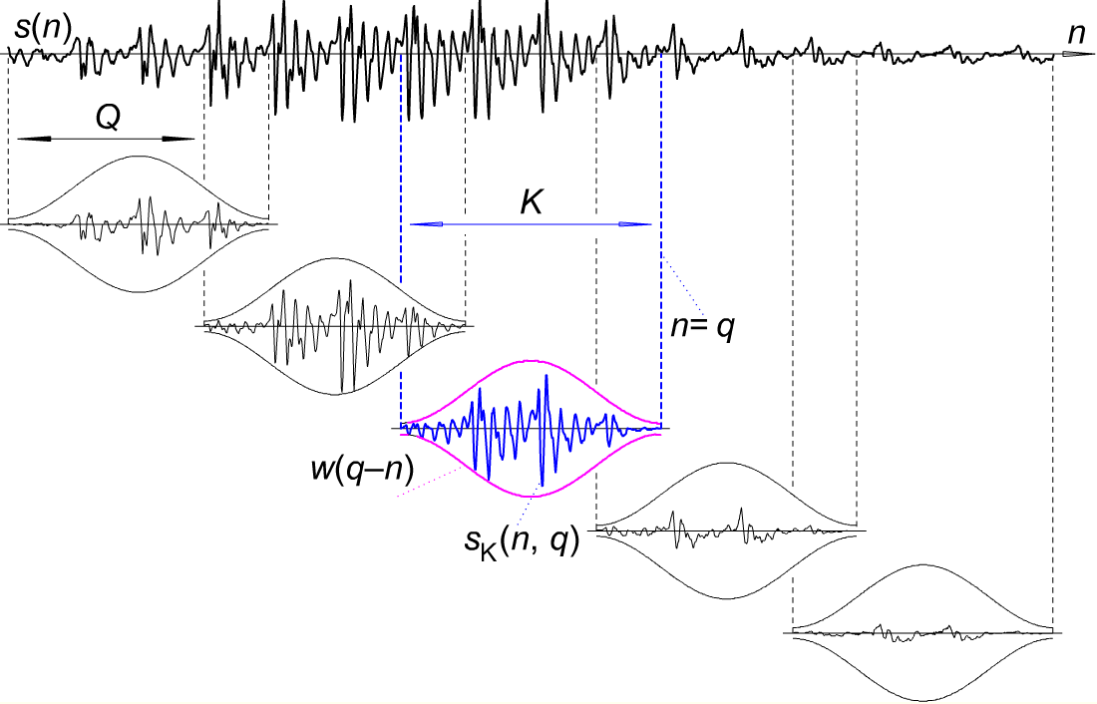

Figure 1. Windowing and Hop size. Q denotes the hop size and K represents the window length [6].

In spectral analysis, the Fourier Transform of a signal is performed to calculate the magnitude of each frequency component present in a signal. The Fourier Transform is translated into DSP via the discretized and sample based Discrete Fourier Transform (DFT). The mathematical implementation of the Fourier Transform and DFT is shown in Equation 2 and 3.

Let be a random function. Then the Fourier Transform of the function is given as follows:

Where is the complex imaginary unit and is the frequency.

Then the DFT for number of samples is given by:

Each value of denotes a frequency bin. The magnitude and phase of the frequency bin is calculated by using Equations 3 and 4.

Let be a complex number where is the imaginary unit.

An algorithm that improves the implementation of the DFT is the Fast Fourier Transform (FFT) algorithm. It requires fewer computational steps to calculate the DFT.

The spectral information calculated using DFT can be represented by graphing the magnitude for each frequency bin or spectrograms. The graphing method provides the harmonic contents of the signal as a function of its magnitude, whereas a spectrogram provides the magnitude of the harmonic contents, or frequency bins, as a function of time. Figure 2 and Figure 3 contain the graphing and spectrogram representations.

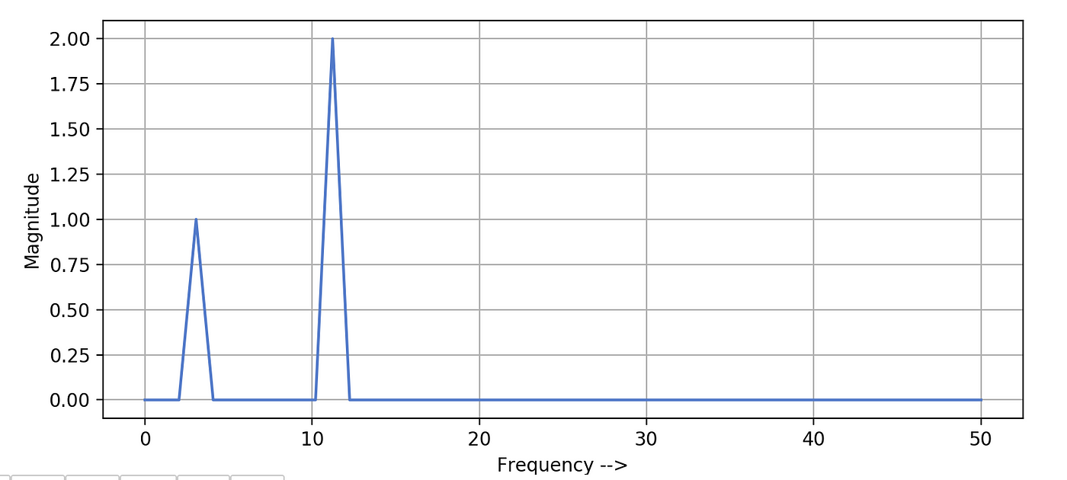

Figure 2. Graphing Frequency as a Function of Magnitude [5].

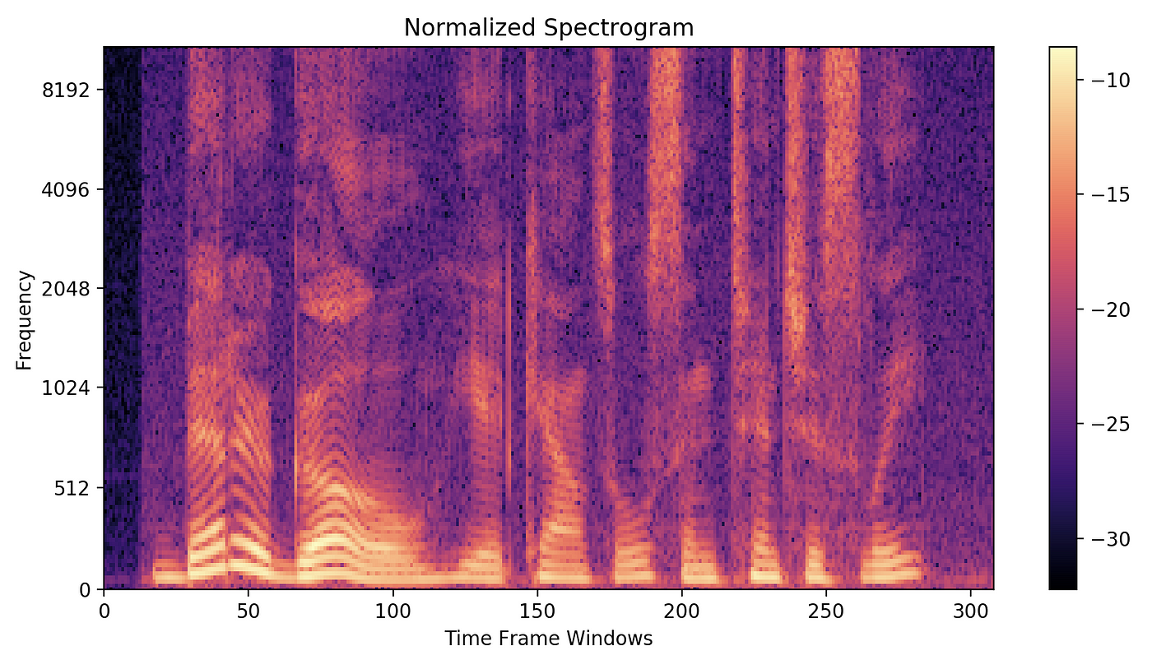

Figure 3. Spectrogram [5].

The lowest resonant frequency component present in the signal is known as the fundamental frequency. In a periodic signal, multiples of the fundamental frequency are known as the harmonics or overtones [8.]

It is quite valuable to apply the windowing when calculating the DFT of data to optimize accuracy or performance. The windows are often truncated by applying various window functions such that the samples taper to zero at the start and the end of the window. It is beneficial to apply windowing functions to the window when performing spectral analysis to avoid the effect of spectral leakage. The phenomenon of spectral leakage causes the magnitude information of a frequency bin affects the other frequency bin [9]. This is often caused due to the overlapping windows causing discontinuities in the signal, as shown in Figure 4.

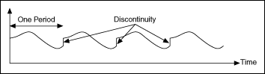

Figure 4. Discontinuities Produced due to No Window Function [8].

## Octaver Algorithm and Model

## YIN Algorithm

## Pickup Fundamentals and Technology

# Testing Prerequisites and Methods

To test the octaver and YIN algorithm, a bass guitar was modified and to house humbucker in a split-coil setup and a piezo pickup. A python script to correlate the data of the two pickups was designed.

## Debugging PCB and Bass Modifications

## Python Testing Script and Sonic Visualizer

## Test Data

## Considerations

# Results

## Data Correlation

## Error Cases and Types

## Pickup Types and Effects

# Discussion

# Conclusion

References

* 1. <https://en.wikipedia.org/wiki/Timbre#:~:text=In%20music%2C%20timbre%20(%2F%CB%88,choir%20voices%20and%20musical%20instruments>.
  2. <https://www.analog.com/en/design-center/landing-pages/001/beginners-guide-to-dsp.html>
  3. <https://www.analog.com/en/design-center/glossary/sampling-rate.html>
  4. <http://musicweb.ucsd.edu/~trsmyth/digitalAudio171/Nyquist_Sampling_Theorem.html>
  5. <https://towardsdatascience.com/all-you-need-to-know-to-start-speech-processing-with-deep-learning-102c916edf62#:~:text=Window%20length%20is%20the%20length,portion%20of%20the%20window%20length>. Harsh Maheshwari
  6. <https://dsp.stackexchange.com/questions/40784/what-is-the-relation-between-windowing-and-hopping-in-audio-dsp> Laurent Duval
  7. <https://towardsdatascience.com/understanding-audio-data-fourier-transform-fft-spectrogram-and-speech-recognition-a4072d228520> Karthik Chaudary
  8. <http://hyperphysics.phy-astr.gsu.edu/hbase/Waves/funhar.html>
  9. <https://www.physik.uzh.ch/local/teaching/SPI301/LV-2015-Help/lvanlsconcepts.chm/Spectral_Leakage.html#:~:text=In%20spectral%20leakage%2C%20the%20energy,exactly%20repeats%20throughout%20all%20time>.

Use one of the referencing systems below. Remove the one that you do not use.

Harvard (author-date) system:

The reference list entries need to be in alphabetical order according to the last name of the author mentioned first in the list of authors.

Davies, Barbara; Jameson, Peter & Smith, John. 2013. Advanced economics. Oxford: Oxford University Press.

Mitchell, John Arnold & Thomson, Magdalena. 2017. A guide to citation. London: London Publishings.

Vancouver (numbering) system:

1. Mitchell, John Arnold & Thomson, Magdalena. 2017. A guide to citation. London: London Publishings.
2. Davies, Barbara; Jameson, Peter & Smith, John. 2013. Advanced economics. Oxford: Oxford University Press.

Title of the Appendix

The appendices are not inserted into the table of contents automatically. Instead, they must be mentioned separately just below the auto-generated part of the table of contents.

Should you insert figures or tables into an appendix, Word numbers them automatically as if they were in the thesis main section. Fix the numbering of figures and tables in the appendixes manually so that the numbering starts from one in each appendix.

Below are instructions for adding and removing attachments so that the headers remain correct.

Instructions for adding a new attachment:

1. Move the cursor to the end of the last existing attachment page.
2. Choose the “Page Layout” tab. From the ribbon select “Page Break” / “Next Page” under “Section Breaks”. This completes the printing of the new attachment, but the number in its header is not correct.
3. Double tap the header of the new attachment page with the wrong attachment number. If the “Link to previous” option is selected in the ribbon, press that button so that the option is no longer selected.
4. Please correct the attachment number.

Instructions for removing an unnecessary attachment:

1. First select the entire attached page and press “Delete” to delete its contents.
2. When you are at the beginning of the attachment page you have emptied (see figure), double tap the header of the blank attachment page and press the “Link to Previous” button on the ribbon. The dialogue box appears (figure 1). Answer “Yes”.



Figure 1. Confirmation of deleting a header.

1. From the “Home” tab, toggle hidden characters if they are not visible:Piilomerkki painikkeen kuvake
2. Remove the section break before the unnecessary attachment (figure 2).



Figure 2. Removal of a section break.

.

Title of the Appendix

Content of the appendix is placed here